

**Key financial metrics on Australia’s higher education sector - December 2016**

**ISSN: 2206-9844**

With the exception of the Commonwealth Coat of Arms, TEQSA's logo, any material protected by a trade mark and where otherwise noted, all material presented in this document is provided under a Creative Commons Attribution 3.0 Australia licence: http://creativecommons.Org/licences/by/3.0/au/.

The details of the relevant licence conditions are available on the Creative Commons website (accessible using the link provided) as is the full legal code for the CC BY 3.0 AU licence: http://creativecommons.org/licences/by/3.0/au/legalcode.



The document must be attributed: Tertiary Education Quality and Standards Agency, *Key financial metrics on Australia’s higher education sector – December 2016*.

**Contacts**

More information about the Tertiary Education Quality and Standards Agency, including electronic versions of this report, is available at: http://teqsa.gov.au/news-publications/publications

Comments and enquiries about this report may be directed to:

Communications Manager

Tertiary Education Quality and Standards Agency

Level 14/530 Collins Street

MELBOURNE VIC 3001

T: 1300 739 585

F: 1300 739 586

E: [collections@teqsa.gov.au](mailto:collections@teqsa.gov.au)

Contents

Introduction 4

1. The sector at a glance 6

2. Sector financial profile 8

3. Provider type 12

4. Key financial metrics 14

5. Revenue from international students 28

Appendix A: Universities 34

Appendix B: For-Profit 37

Appendix C: Not-For-Profit 40

Appendix D: TAFE 43

Appendix E: Provider size - Key financial metrics and international student revenue 46

Explanatory notes 53

Glossary 54

Introduction

This report is the second release of financial information held by Tertiary Education Quality and Standards Agency (TEQSA). It provides a snapshot of selected key financial metrics across the Australian higher education sector. Data in this report has been sourced from TEQSA’s 2015 data collection and relates to financial years ended 31 December 2014 until 30 June 2015.

TEQSA is committed to ensuring that stakeholders in Australia’s higher education sector have access to relevant information to enable and better inform decision making. TEQSA works closely with the Department of Education and Training and other agencies to collect data on the sector and to minimise the regulatory burden on providers. As part of its ongoing monitoring and quality assurance role TEQSA collects and then analyses this data.

The first edition of this report was released in April this year following a period of consultation and was well received by the sector. TEQSA intends to release this report on an annual basis using data from the latest available collection year.

About this report

Assessing the financial position and performance of a provider is a complex process which involves analysing a number of quantitative metrics and understanding the provider’s operating context, mission, governance and management structures. TEQSA conducts an annual financial assessment of each provider, which analyses ten commonly-accepted financial metrics reflecting the key business drivers critical to financial viability and sustainability. TEQSA consulted with the sector prior to adopting these financial metrics in 2013, and received broad support for their adoption.

This report provides a snapshot of selected key financial metrics across the whole sector. The metrics have been selected for their importance in measuring the capacity and capability of providers to deploy financial resources in a way that supports quality in the delivery of higher education. Importantly, the selected metrics are reasonably comparable across all providers and also provide visibility of financial position and performance at sector and sub-sector levels.[1] The definitions and calculation methodology for each measure is available in the Glossary section of this report.

Special focus area in this report – International Student Revenue

This report includes a new special focus section featuring additional analysis on a topic of interest for the sector – **Revenue from International Students**. International student revenue accounted for 16% of sector revenue in the latest reporting year. It was the largest source of revenue for 18% of all providers and for 46% of For-Profit providers. International student revenue are a major revenue source for many providers complementing revenue from other sources.

Purpose of this report

TEQSA recognises that there is little publicly available information on Australia’s higher education sector beyond the university sector. Broadly, this report aims to enhance and improve the level of publicly available financial information on the whole of Australia’s higher education sector with a view to better informing decision making by sector stakeholders.

For many providers financial data is commercial-in-confidence; therefore, information in this report has been presented in an aggregated, de-identified manner. The analysis and key metrics presented in this report allow users, in particular existing higher education providers, to better understand how their entity’s financial performance compares with other similar providers and the sector more broadly.

Each registered higher education provider has been provided a copy of its organisation’s standing against each metric.

Provider groupings used in this report

For the purposes of this report, TEQSA has grouped providers by broad operating model, and by provider EFTSL size bands. The provider operating types used in this report are: Universities, Technical and Further Education (TAFE), Non-University For-Profit (For-Profit) and Non-University Not-For-Profit (Not-For-Profit).

Provider exclusions and inclusions

There are a small number of providers that were not required to submit financial data to TEQSA in the collection year due to contextual factors such as: being recently registered as a higher education provider; or at the time of the data collection, in the process of merging with another entity; withdrawing its registration (i.e. due to teach out of courses); or having its registration cancelled.

In addition to the exclusions identified above, in a handful of cases irregular or abnormal data points have been excluded from the analysis to avoid misleading interpretations of individual provider financial situations. Providers have also been excluded where insufficient data was available to calculate a particular financial metric. As a result, the number of providers presented in a particular chart may be less than the total number of providers listed for the respective provider type or size band. Further details on exclusions can be found in the Appendices and Explanatory Notes sections of this report.

Reporting period

Data in this report has been sourced from TEQSA’s 2015 data collection and relates to financial years ended 31 December 2014 until 30 June 2015.

Enquiries

For enquiries relating to this report or Provider Information Request (PIR) data please contact TEQSA at [collections@teqsa.gov.au](mailto:collections@teqsa.gov.au).

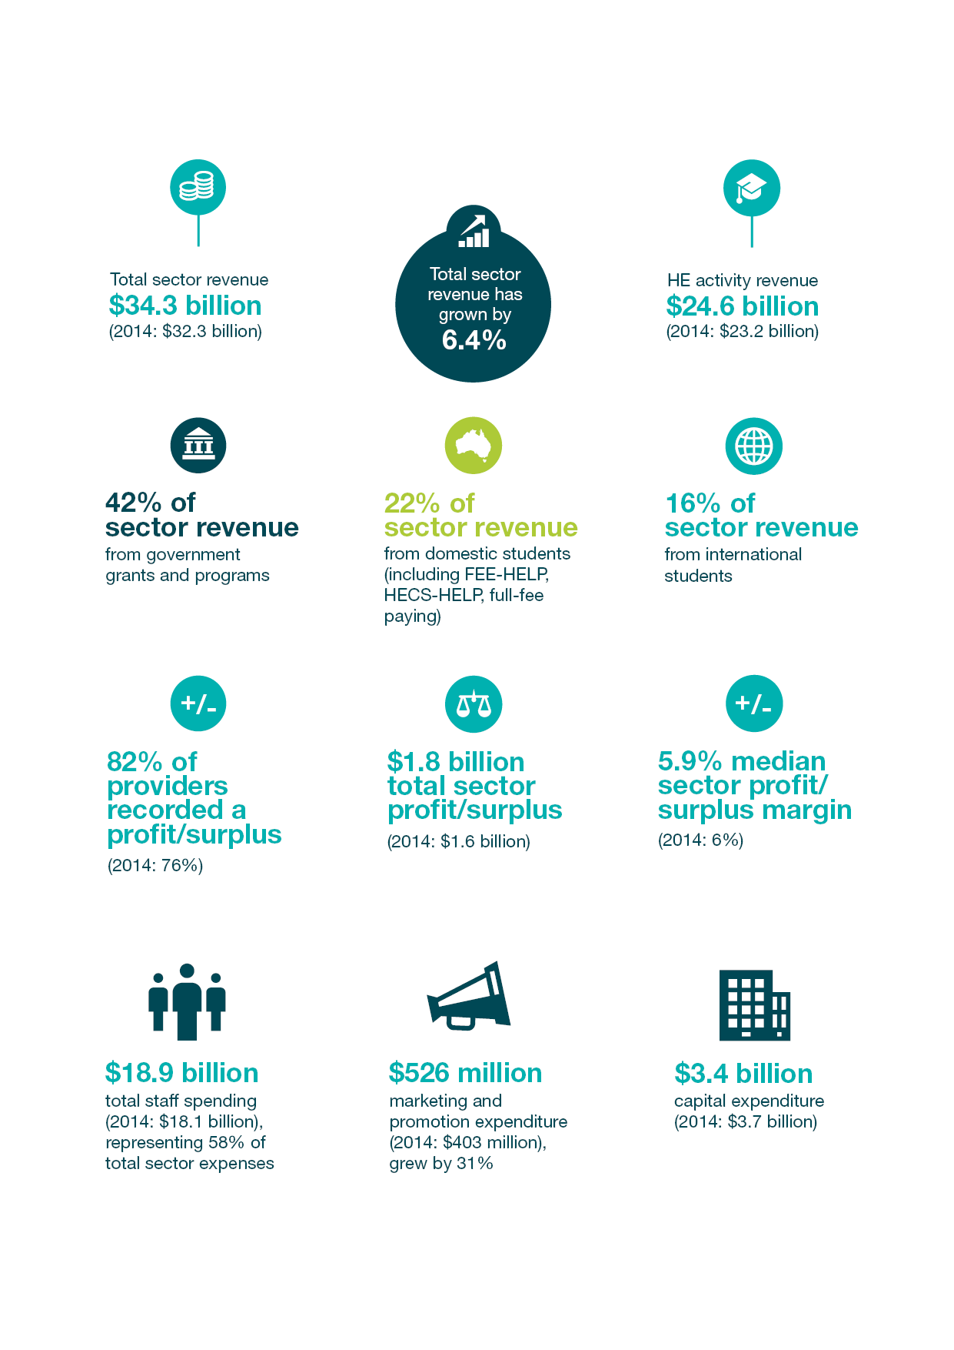1. The sector at a glance

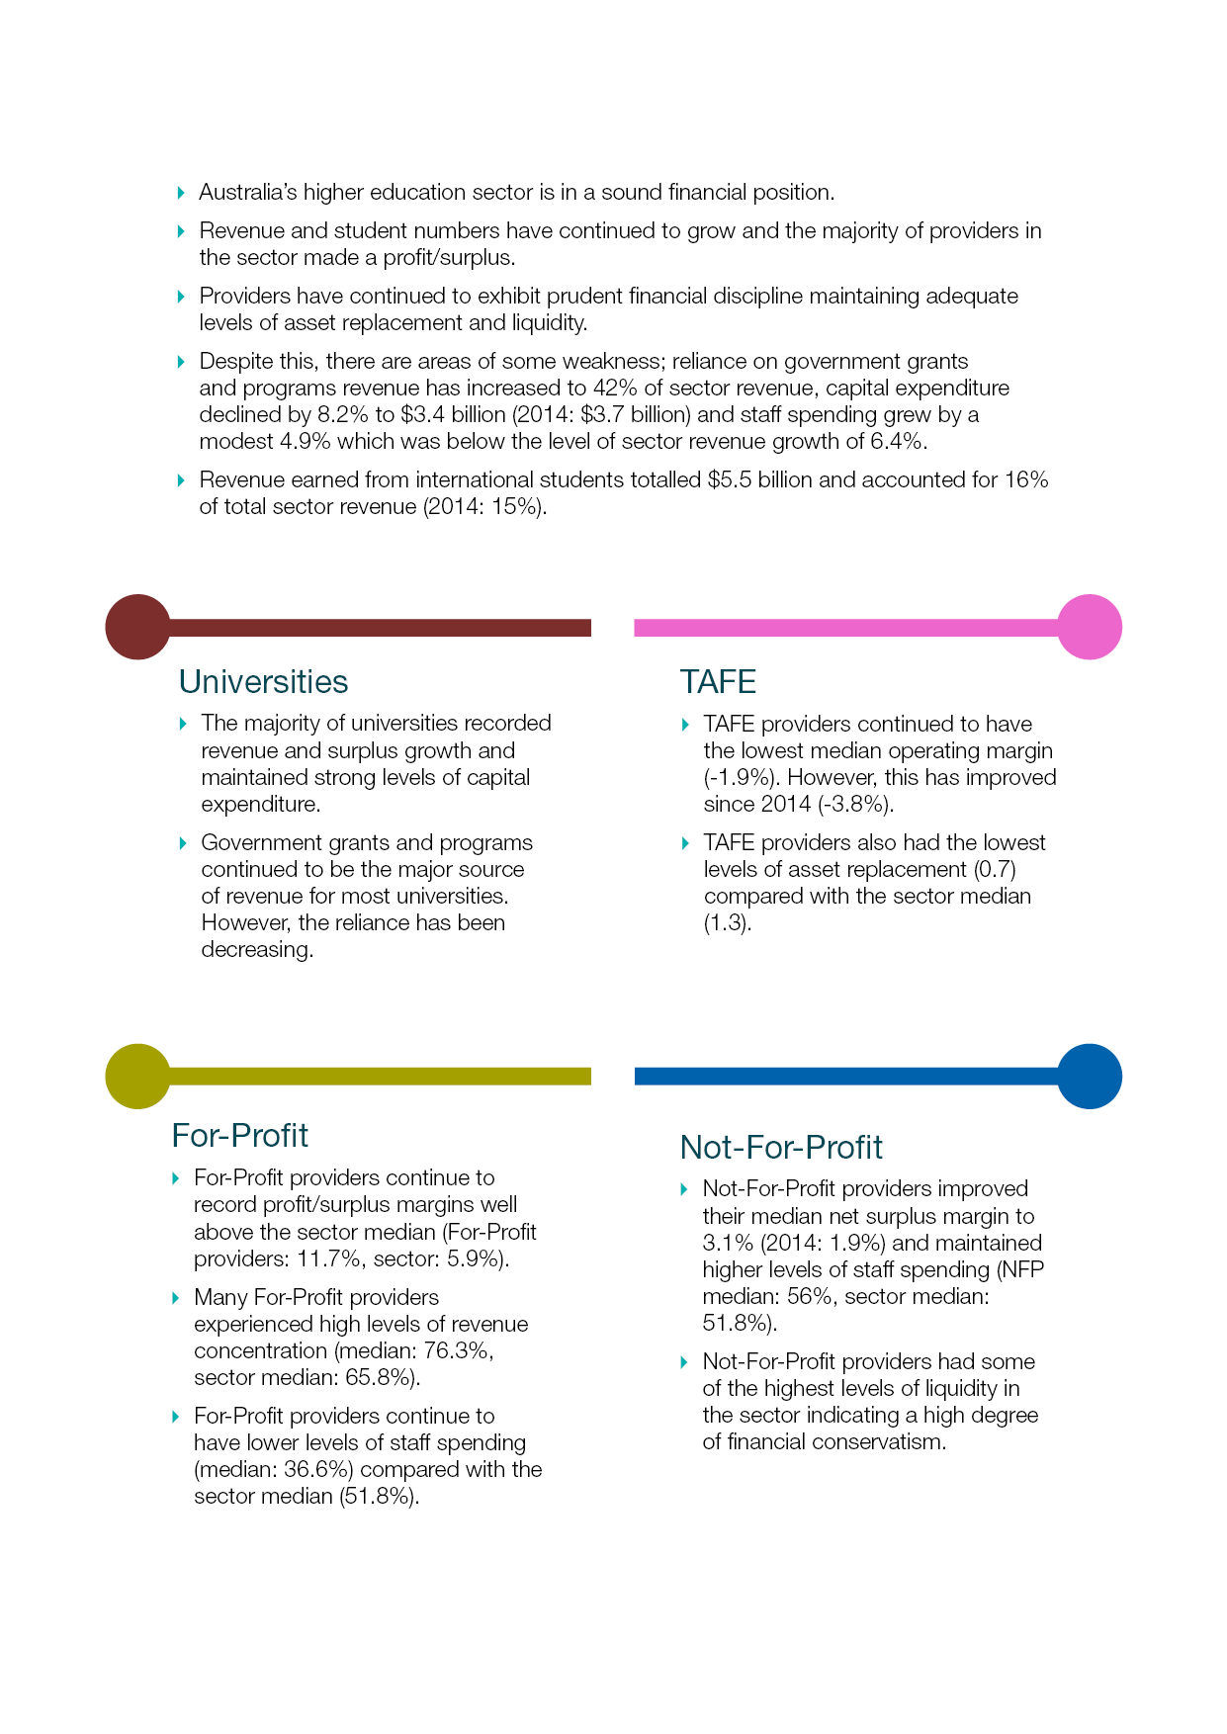Highlights

2. **Sector financial profile**

The higher education sector is large and diverse, and it comprises an important part of the Australian economy. In August 2016 there were 170 providers registered by TEQSA, each with their own operating mission and model. The diversity of provider operating models reflects the depth and scale of market demand for higher education services. The table below summarises the financial performance of the sector in the 2014 and 2015 TEQSA collection years.

**Table 1: Summarised sector financial performance**

|  |  |  |
| --- | --- | --- |
| **$M** | **2014[2]** | **20152** |
| **Revenue** |  |  |
| Higher education | 23,234 | 24,619 |
| VET[3] | 1,446 | 2,301 |
| Other | 7,574 | 7,405 |
| **Total revenue[4]** | **32,254** | **34,325** |
| **Expenses** |  |  |
| Staffing | (18,084) | (18,974) |
| Depreciation | (1,794) | (1,918) |
| Finance costs | (169) | (216) |
| Marketing and promotion | (403) | (526) |
| Other expenses | (10,174) | (10,902) |
| **Total expenses**4 | **(30,624)** | **(32,537)** |
| **Total net surplus/profit[5]** | **1,630** | **1,788** |
| Capital expenditure | 3,691 | 3,387 |
| Total net assets[6] | 54,233 | 56,798 |

*Source: TEQSA analysis; 2014 and 2015 PIR; Department of Education and Training; provider financial statements.*

* In 2015, the total reported revenue was $34.3 billion (2014: $32.3 billion). This represented growth of 6.4%. The key driver has been increased higher education activity revenue which accounted for two-thirds of the growth.
* Despite accounting for a relatively smaller proportion of total sector revenue, revenue from VET activities also grew strongly. Revenue from other activities such as commercial operations and donations totalled $7.4 billion.
* Total sector expenditure increased by 6.2% to $32.5 billion in 2015 (2014: $30.6 billion). The growth in expenditure was slightly lower than total sector revenue growth, contributing towards the increase in the total sector net surplus/profit.
* Spending on staff (2015: $18.9 billion, 2014: 18.1 billion), continued to account for the largest area of sector expenditure. In 2015, staff spending accounted for 58.3% (2014: 59.1%) of total sector expenditure. Alternatively measured staff spending represented 55.3% of total sector revenue. Staffing expenditure increased by 4.9% in 2015, which was slower than the rate of revenue growth over the same period.
* The total aggregate profit/surplus recorded by the sector was approximately $1.8 billion, which represented growth of 9.7% when compared with the previous year’s result. This result equated to a total sector net surplus/profit margin of 5.2%, which was similar to the margin recorded in 2014 of 5.1%.
* Capital expenditure declined to approximately $3.4 billion. This constituted a decline of 8.2% from 2014 of $3.7 billion.
* The total net assets (i.e. net worth) of the sector increased by 4.7%, to $56.8 billion.

Sector revenue by source

Figure 1 below summarises the key sources of sector revenue. These sources reflect the main stakeholders in Australia’s higher education sector such as the Australian Government, domestic students and international students. Revenue derived from the FEE-HELP and HECS HELP schemes have been classified as ‘Higher education domestic students’ reflecting the student’s contribution to their tuition. The category of ‘Non-higher education’ includes tuition and related fees associated with VET, ELICOS and non-award course delivery to both domestic and international students.

**Figure 1: Sector revenue, by source**

* Government grants and programs continued to account for the largest source of sector revenue, 42% in 2015 compared with 40% in 2014. This revenue source includes funding from programs such as the Commonwealth Grants Scheme (CGS), research grants and scholarships.
* Fees received from domestic students studying higher education (inclusive of FEE-HELP, HECS-HELP, full-fee paying income) remained unchanged at 22% of sector revenue.
* Income from international students (onshore and offshore) represented 16% of total revenue, compared with 15% in 2014.

Revenue sources by provider type

This section analyses the revenue sources for each provider type. Figure 2 below shows the revenue sources and the total revenue generated by each provider type.

**Figure 2: Revenue sources, by provider type**

**Universities TAFE**

**Total sector revenue:**

**$34.3 billion**

***$3.6***

***billion***

***$27.6***

***billion***

**For-Profit Not-For-Profit**

***$1.5***

***billion***

***$1.6***

***billion***

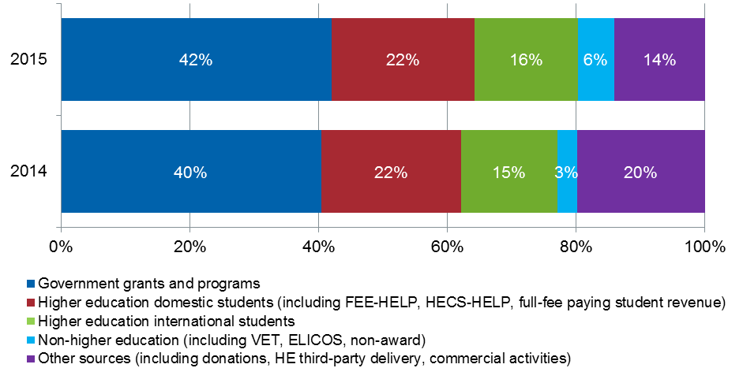

* Universities account for the majority of students in the sector and are largely reliant on government grants and programs revenue.
* TAFE providers were the most reliant on income from government grants and programs which accounted for 55% of revenue.
* Revenue generated by For-Profit providers is from a diverse range of sources. International students, domestic students and non-higher education delivery each accounted for approximately a third of revenue generated.
* Not-For-Profit providers generated 50% of revenue from government grants and programs. However, this is influenced by a handful of providers which have a heavy reliance on government grants.

Expenses by provider type

Figure 3 below shows the breakdown of key expenses as a proportion of total expenditure by each provider type.

**Figure 3: Expenses, by provider type**

**Universities TAFE**

***$26.0 billion***

***$3.7 billion***

**Total sector expense:**

**$32.5 billion**

**For-Profit Not-For-Profit**

***$1.6 billion***

***$1.2 billion***

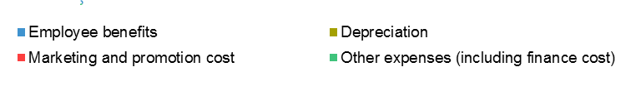

* Staff spending was the largest expense for all provider types, except for For-Profit providers where other expenses such as occupancy, administration, travel and IT accounted for the largest area of expenditure.
* Marketing and promotion expenditure accounted for 15% of For-Profit provider expenditure. However, this accounted for a relatively small area of expenditure for all other provider types.
* Total expenditure for TAFE providers of $3.7 billion exceeded total revenue generated by TAFE providers, indicating that collectively TAFE providers generated a deficit. Profitability is analysed in further detail at Section 4.2.

3. Provider type

In this report, providers have been grouped according to type.

The provider groupings used in this report are: Universities[7], TAFE, For-Profit and Not-For-Profit. Table 2 provides details on the proportion of student load and higher education revenue to the overall sector total by each provider type, as at 12 August 2016. Student data relates to 2014[8].

**Table 2: Breakdown of providers, by type**

|  |  |  |  |
| --- | --- | --- | --- |
| **Provider type** | **Number of  providers** | **% of  students** | **% of HE**  **revenue** |
| Universities | 43 | 93.3 | 94.4 |
| TAFE | 11 | 0.4 | 0.2 |
| For-Profit | 63 | 4.5 | 3.8 |
| Not-For-Profit | 53 | 1.8 | 1.6 |

*Source: TEQSA National Register - 12 August 2016; TEQSA analysis; 2015 PIR; Department of Education and Training; provider financial statements.*

* Universities represent a quarter of all higher education providers, but account for the overwhelming majority of students and higher education revenue in the sector.
* Non-university providers represent three quarters of providers yet account for only 6.7% of students and 5.6% of higher education revenue.

Table 3 below summarises the revenue range for each provider type.

**Table 3: Total revenue range, by provider type**

|  |  |  |  |  |  |  |
| --- | --- | --- | --- | --- | --- | --- |
| **$ million** | **Minimum** | **First quartile** | **Median** | | **Third quartile** | **Maximum** |
| Universities | 1.5 | 287.5 | | 520.9 | 843.5 | 2,108.4 |
| TAFE | 39.8 | 109.6 | | 121.5 | 241.7 | 1,901.4 |
| For-Profit | 0.3 | 5.1 | | 14.4 | 31.0 | 191.9 |
| Not-For-Profit | 0.1 | 1.6 | | 6.0 | 17.9 | 820.4 |
| **Sector** | 0.1 | 5.1 | | 23.6 | 191.6 | 2,108.4 |

* The median provider generated $23.6 million in total revenue.
* There was a great deal of diversity in the total revenue generated by providers with universities and TAFEs generally earning larger amounts in revenue than For-Profit and Not-For-Profit providers.

In addition to provider type, providers have also been grouped according to EFTSL size bands. The analysis of the key financial metrics by provider size is included at **Appendix E**. Table 4 below provides details on the number of providers, students taught and total proportion of higher education revenue for each EFTSL size band.

**Table 4: Breakdown of providers, by total EFTSL bands**

|  |  |  |  |
| --- | --- | --- | --- |
| **Provider size**  **EFTSL** | **Number of  providers** | **% of  students** | **% of higher education**  **revenue** |
| < 100 | 57 | 0.2 | 0.3 |
| 100 ≤ 499 | 33 | 0.9 | 1.0 |
| 500 ≤ 4,999 | 41 | 5.7 | 4.3 |
| 5,000 ≤ 19,999 | 16 | 20.2 | 19.8 |
| ≥ 20,000 | 23 | 73.0 | 74.5 |

*Source: TEQSA National Register - 12 August 2016; TEQSA analysis; 2015 PIR; Department of Education and Training; provider financial statements.*

* All 39 providers with EFTSL greater than 5,000 were universities.

4. Key financial metrics

4.1 Revenue source and concentration

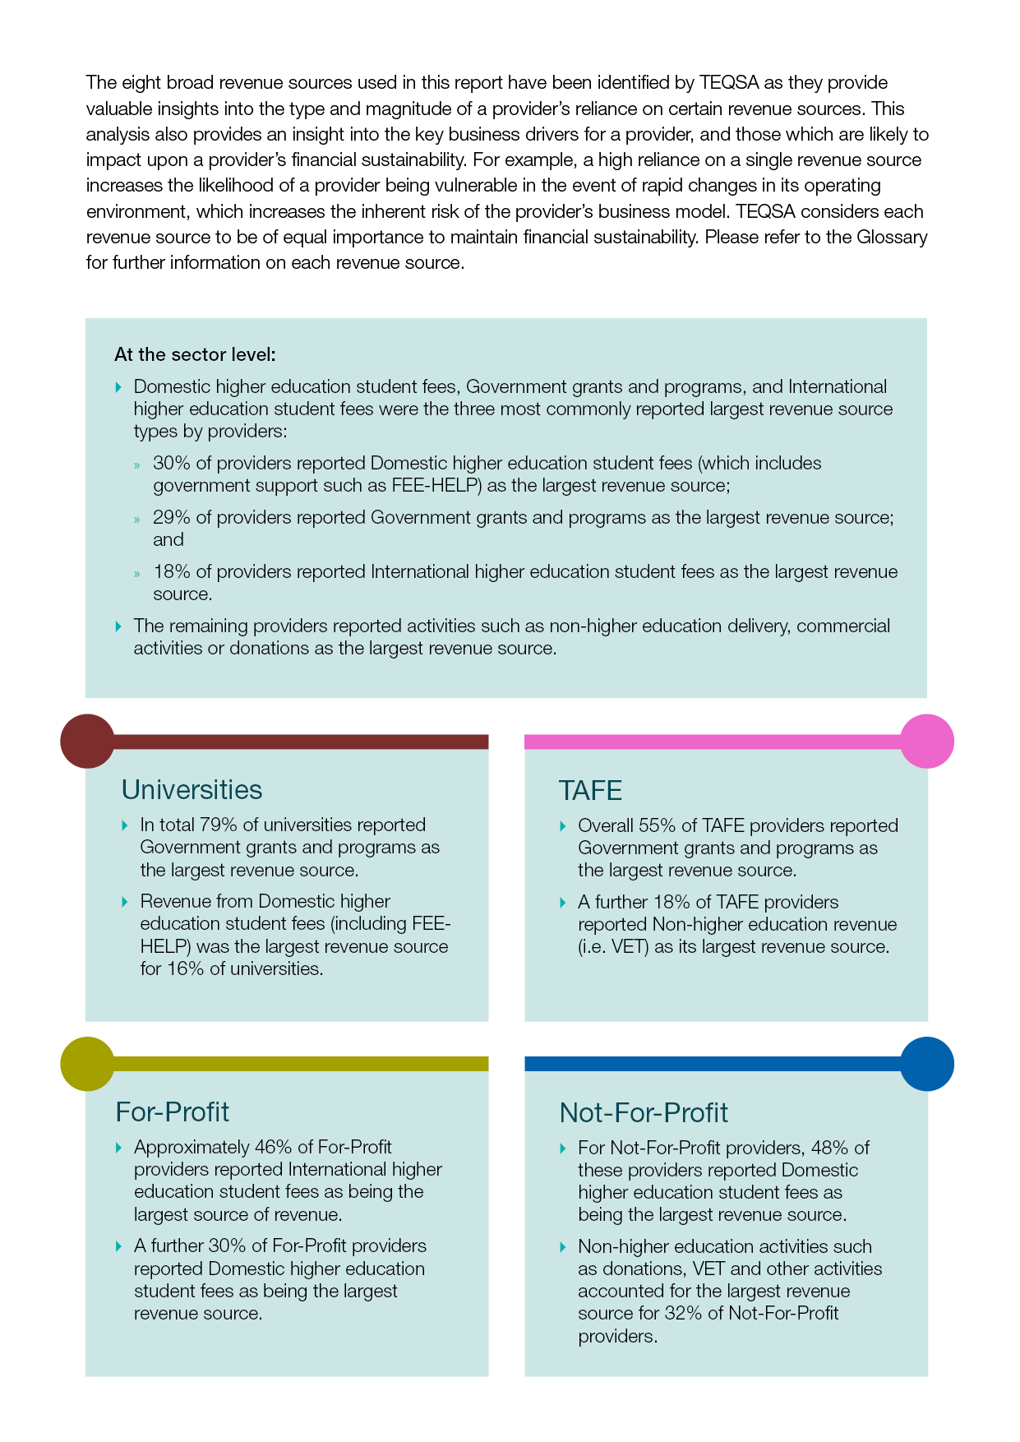Revenue source and concentration provides an indication of the diversity of a provider’s business activities. This is an important factor in assessing the resilience of a provider’s operating model and its capacity to respond to changes in its operating environment. High levels of revenue concentration may impair the provider’s ability to respond effectively to changes in its operating environment. The eight broad revenue sources used in this report have been identified by TEQSA as they provide valuable insights into the type and magnitude of a provider’s reliance on certain revenue sources. TEQSA considers each revenue source to be of equal importance to maintain financial sustainability. Please refer to the Glossary for further information on each revenue source.

In this section, a distribution of the population (i.e. all analysed providers) and a table with quartile values by provider type is presented for each metric. In some cases, further analysis has been presented to provide additional insights.

Revenue concentration

**Figure 4: Revenue concentration, by provider type**







**Table 5: Revenue concentration range, by provider type**

|  |  |  |  |  |  |  |
| --- | --- | --- | --- | --- | --- | --- |
|  | **Minimum** | **First quartile** | **Median** | | **Third quartile** | **Maximum** |
| Universities | 32.0% | 39.1% | | 45.0% | 51.2% | 69.7% |
| TAFE | 31.1% | 48.4% | | 64.3% | 68.5% | 73.8% |
| For-Profit | 39.6% | 51.0% | | 68.7% | 93.8% | 99.7% |
| Not-For-Profit | 37.5% | 48.8% | | 67.8% | 82.6% | 99.7% |
| **Sector** | **31.1%** | **45.2%** | | **56.6%** | **80.4%** | **99.7%** |

* Revenue concentration varied for each provider type. The largest revenue source ranged from 31.1% to 99.7% of total revenue.
* The median provider in the sector had a revenue concentration of 56.6%.
* For-Profit providers had the highest median revenue concentration of 68.7%. As reflected in Figure 4 For-Profit providers were concentrated towards the upper end of the range.

Figure 5 below depicts the composition of provider types in each quartile, noting that each quartile consists of approximately the same numbers of providers. Figure 5 provides an alternate view of the data in Figure 4 and Table 5 above.

For example in Figure 5, 60% of the providers in the first quartile (i.e. those with revenue concentration of less than 45.2%) are universities. This indicates that universities tended to have a lower level of revenue concentration than For-Profit providers, which comprised 60% of the providers in the fourth quartile with a revenue concentration of greater than 80.4% from a single source.

**Figure 5: Revenue concentration, sector wide quartile composition by provider type**

* All of the providers in the fourth quartile, which comprised providers with a revenue concentration of greater than 80.4%, were either For-Profit or Not-For-Profit.

Figure 6 below analyses the proportion of provider types by each quartile. For example, 73% of TAFE providers were in the third quartile with revenue concentration of 56.6% to 80.4%. Figure 6 shows that 42% of For-Profit providers had revenue concentration of greater than 80.4%. Approximately two-third of For-Profit and Not-For-Profit providers had revenue concentrations that were higher than the sector median of 56.6%.

**Figure 6: Revenue concentration, by provider type (quartile)**

* Universities tended to have a lower level of revenue concentration than other provider types, with 91% of universities recording a revenue concentration level below the sector median of 56.6%.

**4.2 Profitability**

The profitability of a provider gives an indication of its ability to generate revenue and manage expenses in order to deliver a profit/surplus. While many higher education providers are not-for-profit in nature (including TAFEs and universities), the generation of a surplus is important in ensuring that the provider can fund its operations into the future. Ideally, accumulated profits/surpluses are used to support or enhance a provider’s capacity to sustain quality in its higher education operations. This report analyses profitability based on two measures: Net Profit/Surplus margin, and the Earnings Before Interest, Taxes, Depreciation and Amortisation (EBITDA) margin.[9]

Net profit/surplus margin

**Figure 7: Net profit/surplus margin, by provider type**







**Table 6: Net profit/surplus margin range, by provider type**

|  |  |  |  |  |  |  |  |  |  |
| --- | --- | --- | --- | --- | --- | --- | --- | --- | --- |
|  | **Minimum** | **First quartile** | | **Median** | | **Third quartile** | | **Maximum** | |
| Universities | -37.0% | | 1.5% | 4.6% | 7.6% | | 13.7% | |
| TAFE | -15.8% | | -7.4% | -1.9% | 5.1% | | 8.7% | |
| For-Profit | -11.5% | | 5.0% | 11.7% | 22.4% | | 54.2% | |
| Not-For-Profit | -38.7% | | -0.3% | 3.1% | 8.8% | | 26.9% | |
| **Sector** | **-38.7%** | | **0.4%** | **5.9%** | **11.0%** | | **54.2%** | |

|  |
| --- |
| * The median net profit/surplus margin for the sector has remained steady at 5.9% compared with 6.0% in the previous year. In 2015, 82% of providers reported a net profit/surplus up from 76% of providers in 2014. |
| * Provider profitability varied depending on provider type. For example, the median profitability of For-Profit providers was 11.7% (2014: 11.9%), which was much higher than other provider types and almost double the sector median of 5.9%. |
| * The median net profit/surplus margin for 2015 compared with 2014 for each provider type was: |
| * Universities: 4.6% (2014: 6.1%) |
| * TAFE: -1.9% (2014: -3.8%). |
| * For-Profit: 11.7% (2014: 11.9%) |
| * Not-For-Profit: 3.1% (2014: 1.9%) |

Figure 8 analyses the proportion of provider type in each quartile. For example, 64% of TAFE providers were in the first quartile with a margin of less than 0.4%. In comparison, 50% of For-Profit providers were in the fourth quartile (i.e. greater than 11% profit/surplus margin).

**Figure 8: Net profit/surplus by provider type (quartile)**

|  |
| --- |
| * The majority of universities (74%) were in the second and third quartiles. * For-Profit providers recorded the highest profit margins in the sector with 50% of For-Profit providers in the fourth quartile with a profit margin greater than 11%. A further 21% of For-Profit providers were in the third quartile with a profit margin of 5.9% to 11%. * In total, 63% of Not-For-Profit providers recorded a margin below the sector median. * Approximately two-third of TAFE providers were in the first quartile, indicating very low levels of profitability. |

EBITDA margin

The alternative profit/surplus measure of EBITDA (Earnings Before Interest, Taxation, Depreciation and Amortisation) has been included in this report. The use of the EBITDA margin allows for the profitability of providers to be assessed on a more comparable basis as it provides a view of profitability which removes the impact caused by different capital structures, depreciation policies, non-operating expense items and taxation rates. Net profit/surplus is a measure of profitability which includes interest, taxation and the non-cash items of depreciation and amortisation. Typically, EBITDA will be greater than net profit/surplus.

**Figure 9: EBITDA margin, by provider type**







**Table 7: EBITDA margin range, by provider type**

|  |  |  |  |  |  |  |  |  |  |
| --- | --- | --- | --- | --- | --- | --- | --- | --- | --- |
|  | **Minimum** | **First quartile** | | **Median** | | **Third quartile** | | **Maximum** | |
| Universities | -36.9% | | 6.4% | 10.5% | 13.8% | | 19.4% | |
| TAFE | -10.5% | | -1.1% | 1.5% | 7.7% | | 13.9% | |
| For-Profit | 0.0% | | 11.8% | 17.2% | 31.8% | | 98.1% | |
| Not-For-Profit | -77.2% | | 0.3% | 5.5% | 14.3% | | 37.7% | |
| **Sector** | **-77.2%** | | **3.6%** | **11.1%** | **17.8%** | | **98.1%** | |

|  |
| --- |
| * The median EBITDA margin for the sector has remained relatively steady at 11.1% (2014: 11.4%). * Very few providers recorded a negative EBITDA margin indicating that the vast majority of providers were effectively managing their financial resources. * The median EBITDA margin for 2015 compared with 2014 for each provider type was:   + Universities: 10.5% (2014: 11.4%)   + TAFE: 1.5% (2014: 1.9%).   + For-Profit: 17.2% (2014: 16.6%)   + Not-For-Profit: 5.5% (2014: 5.2%). |

4.3 Employee benefits ratio

Employees are critical to the effective delivery of a provider’s higher education objectives. Staff spending (academic and non-academic) is typically the largest recurring cost item for many providers. The Employee Benefits Ratio (EBR) provides an indication of the total staff spending (full-time, fractional full-time, casual, contract) relative to the provider’s level of revenue.[10] A provider’s EBR can be influenced by a range of factors such as the composition of a provider’s workforce (i.e. full-time, fractional full-time or casual), delivery method (face-to-face, online, third party) or provider mission. For example, it is possible for providers to have an EBR of zero in situations when staff are engaged on a volunteer basis.

**Figure 10: Employee benefits ratio, by provider type**





**Table 8: Employee benefits ratio range, by provider type**

|  |  |  |  |  |  |  |
| --- | --- | --- | --- | --- | --- | --- |
|  | **Minimum** | **First quartile** | **Median** | | **Third quartile** | **Maximum** |
| Universities | 13.2% | 53.3% | 56.7% | 58.8% | | 83.9% |
| TAFE | 54.0% | 60.3% | 69.1% | 71.9% | | 85.3% |
| For-Profit | 0.0% | 22.2% | 36.6% | 46.0% | | 63.3% |
| Not-For-Profit | 19.2% | 43.0% | 56.0% | 65.3% | | 83.7% |
| **Sector** | **0.0%** | **37.7%** | **51.8%** | **59.1%** | | **85.3%** |

|  |
| --- |
| * For-Profit providers had the lowest median EBR (36.6%) in the sector. |
| * Not-For-Profit, TAFEs and Universities all had median EBRs above the sector median of 51.8%. |
| * Not-For-Profit and TAFE providers comprised the majority of providers with the highest EBR. |
| * All provider types experienced an increase in the median EBR compared with 2014 except for For-Profit providers: |
| * Universities: 56.7% (2014: 55.2%) |
| * TAFE: 69.1% (2014: 69.0%) * For-Profit: 36.6% (2014: 39.2%) * Not-For-Profit: 56.0% (2014: 55.0%). |

Figure 11 depicts the composition of provider types in each quartile, noting that each quartile consists of approximately the same number of providers. The analysis shows that For-Profit providers represent 75% of the providers in the first quartile (i.e. with an EBR of less than 37.7%). This indicates that For-Profit providers tended to have a lower EBR than universities, which comprised 59% of the providers in the third quartile which had an EBR between 51.8% and 59.1%.

**Figure 11: Employee benefits ratio, sector wide quartile composition by provider type**

|  |
| --- |
| * A large proportion (75%) of providers in the first quartile, with an EBR of less than 37.7%, were For-Profit providers. Furthermore the median EBR recorded by For-Profit providers has declined from 39.2% in 2014 to 36.6% in 2015, indicating that staff spending as a proportion of revenue has reduced. * In comparison, Figure 11 shows that TAFE providers were only found in the third and fourth quartiles meaning that all TAFE providers had an EBR above the sector median of 51.8%. |
| * Only 3% of universities were found in the first quartile. |

4.4 Asset replacement

Physical resources such as leasehold improvements, IT equipment, libraries, furniture and buildings are necessary for providers to achieve their higher education objectives. These items are typically depreciated over their useful lives. Over time, accumulated depreciation reduces the carrying value of these items. In order to maintain a consistent level of physical resourcing and to avoid the impact of large unexpected capital expenditures, it is considered sound practice to reinvest at a rate that is comparable to, or greater than, the rate of depreciation. The asset replacement ratio not only provides an indication of how a provider is managing its assets but also whether an unanticipated capital expenditure event is likely.[11]  A ratio above 1 indicates recent investment in physical resourcing (such as refurbishment, replacing existing assets, purchase of new assets).

**Figure 12: Asset replacement ratio, by provider type**







**Table 9: Asset replacement ratio range, by provider type**

|  |  |  |  |  |  |  |
| --- | --- | --- | --- | --- | --- | --- |
|  | **Minimum** | **First quartile** | **Median** | | **Third quartile** | **Maximum** |
| Universities | 0.7 | 1.8 | | 2.1 | 3.0 | 14.2 |
| TAFE | 0.5 | 0.6 | | 0.7 | 1.1 | 2.9 |
| For-Profit | 0.0 | 0.5 | | 0.9 | 1.9 | 10.3 |
| Not-For-Profit | 0.0 | 0.5 | | 1.0 | 2.3 | 12.6 |
| **Sector** | **0.0** | **0.6** | | **1.3** | **2.4** | **14.2** |

|  |
| --- |
| * The median asset replacement ratio for the sector was 1.3, reflecting a healthy level of reinvestment in assets. |
| * There was a general decline in the rate of asset replacement compared with 2014 when a median of 1.7 was observed. Most provider types experienced a decline in the median asset replacement rates compared with 2014. The median asset replacement ratio for 2015 compared with 2014 for each provider type was: * Universities: 2.1 (2014: 2.4) * TAFE: 0.7 (2014: 0.7) * For-Profit: 0.9 (2014: 1.1) * Not-For-Profit: 1.0 (2014: 1.4). |
| * Universities had a median asset replacement ratio of 2.1 which was far greater than the sector median and well above the accepted benchmark of 1. This indicates that universities were not merely replacing assets but also investing in new assets. |
| * The median asset replacement ratio for For-Profit providers was below the sector median but close to the generally accepted benchmark of 1, indicating that investment was generally replacement in nature. * For-Profit and TAFE providers recorded median asset replacement ratios of 0.9 and 0.7 respectively which were below the sector median of 1.3 indicating that the rate of investment in assets was below depreciation. |

4.5 Liquidity

Liquidity, commonly measured using the current ratio[12], provides an indication of a provider’s capacity to meet short-term financial obligations within its ordinary operating cycle (typically up to 12 months). This ratio provides a snapshot of a provider’s capacity to meet its short-term financial commitments at a particular point in time. A ratio of 1 or above indicates that a provider has a strong capacity to meet its short-term financial commitments within its ordinary operating cycle.

**Figure 13: Liquidity, by provider type**







**Table 10: Liquidity range, by provider type**

|  |  |  |  |  |  |  |
| --- | --- | --- | --- | --- | --- | --- |
|  | **Minimum** | **First quartile** | **Median** | | **Third quartile** | **Maximum** |
| Universities | 0.3 | 1.0 | | 1.4 | 2.2 | 5.3 |
| TAFE | 0.5 | 1.0 | | 1.4 | 2.4 | 3.1 |
| For-Profit | 0.3 | 0.7 | | 1.1 | 1.9 | 10.2 |
| Not-For-Profit | 0.2 | 1.1 | | 1.6 | 2.9 | 13.6 |
| **Sector** | **0.2** | **0.9** | | **1.4** | **2.2** | **13.6** |

|  |
| --- |
| * All provider types recorded a median current ratio of greater than 1, indicating adequate liquidity levels are being maintained across the sector. * Overall, 71.7% of providers had liquidity levels above 1, the generally accepted benchmark. * Liquidity levels in 2015 were comparable to 2014 levels (sector median: 1.3). * For-Profit providers accounted for 55% of providers with liquidity level of below 0.9 (i.e. the first quartile), indicating that additional liquidity may be required for some providers. * Not-For-Profit providers had the highest median liquidity of 1.6 and accounted for 40% of those providers with the highest levels of liquidity (i.e. greater than 2.2), indicating a conservative approach in the management of financial resources. * Liquidity levels in 2015 were comparable to 2014 levels (sector median: 1.3).The median liquidity levels for 2015 compared with 2014 for each provider type was: * Universities: 1.4 (2014: 1.4) * TAFE: 1.4 (2014: 1.1) * For-Profit: 1.1 (2014: 1.1) * Not-For-Profit: 1.6 (2014: 1.4). |

5. Revenue from international students

This section includes additional analysis of international student revenue which are an important source of revenue for many providers.

In the latest reporting year, there were over 0.26 million international students[13] (covering both onshore and offshore enrolments) studying an Australian course. This represented 27% of all students. Enrolments from international students have grown to become an important source of revenue for Australian higher education providers. In total, 125 providers had enrolled international students, representing 79% of providers in the sector. Table 11 shows that all 43 universities have international student enrolments and collectively accounted for 89.5% of international student enrolments in the sector. In comparison, only half of Not-For-Profit providers enrol international students.

**Table 11: Breakdown of international student EFTSL, by provider type**

|  |  |  |  |
| --- | --- | --- | --- |
|  | **International**  **student EFTSL  (‘000)** | **Proportion of**  **providers with**  **international students** | **Proportion of**  **international**  **students** |
| Universities | 233.2 | 100.0% | 89.5% |
| TAFE | 1.5 | 81.8% | 0.6% |
| For-Profit | 22.3 | 84.2% | 8.6% |
| Not-For-Profit | 3.4 | 50.0% | 1.3% |

*Source: TEQSA analysis; 2015 PIR; Department of Education and Training*

In the latest reporting year, revenue earned from international students totalled $5.47 billion and accounted for 16% of total sector revenue (2014: 15%).

Figure 14: Total international student revenue ($), by provider type





* Figure 14 shows that universities accounted for much of the international student revenue generated by the sector.
* There were 38 providers that generated less than $1 million in international student revenue.

Figures 15 and 16 below examine the growth in international student revenue by provider type.

Figure 15: Total international student revenue ($), by provider type

* The amount of international student revenue varied across the provider types. Nonetheless, all provider types experienced growth in international student revenue.
* Universities generated close to $4.8 billion in international student revenue, an increase of 10.4% from 2014. This represented 87% of the sector’s international student revenue.
* Not-For-Profit providers collectively received $149.4 million in fees from higher education international students, a 47.8% increase from 2014.

Figure 16: International student revenue growth ($), by provider type

∆ 21.1%

∆ 47.8%

∆ 31.6%

∆ 10.4%

**12.9% growth**

* Revenue from international students grew by 12.9% in 2015.
* Universities and For-Profit providers collectively accounted for $575 million of the growth in 2015, which equated to 91.7% of the total growth.
* Not-For-Profit and For-Profit providers experienced the largest annual rates of growth recording 47.8% and 31.6% respectively.

The analysis in Figure 17 below refers to international student revenue as a proportion of higher education activity revenue. Providers with no international student enrolments have been removed from the analysis presented in Figure 17 and Table 12.

Figure 17: International student revenue as proportion of higher education activity revenue, by provider type





* Providers with a high reliance on international student revenue (i.e. over 50% reliance) were predominately For-Profit providers.
* Revenue from international students generally accounted for 10% to 35% of universities higher education revenue, except for a few universities on either side of the distribution.
* Not-For-Profit and TAFE providers’ reliance on international student revenue varied widely.

Table 12 below shows the proportion of international student revenue relative to higher education revenue for each provider type.

**Table 12: International student revenue to total higher education revenue, by provider type**

|  |  |  |  |  |  |  |
| --- | --- | --- | --- | --- | --- | --- |
|  | **Minimum** | **First quartile** | **Median** | | **Third quartile** | **Maximum** |
| Universities | 1.7% | 12.5% | | 19.3% | 23.8% | 81.5% |
| TAFE | 2.5% | 14.3% | | 34.1% | 44.2% | 72.9% |
| For-Profit | 0.1% | 13.6% | | 79.5% | 98.7% | 100.0% |
| Not-For-Profit | 0.6% | 2.7% | | 4.8% | 21.3% | 96.3% |
| **Sector** | **0.1%** | **9.2%** | | **20.5%** | **73.7%** | **100.0%** |

* The concentration of For-Profit providers towards the upper end of the range in Figure 17 is also reflected in Table 12 which shows that the median international student revenue proportionate to higher education revenue to be 79.5%. This is not only higher than the sector median, but also higher than the sector third quartile of 73.7%.
* In contrast, Not-For-Profit providers had the lowest median proportion of international student fees relative to total higher education revenue of 4.8%.
* Despite generating 87% of the sector’s international student revenue, universities median international student revenue proportion was 19.3% of its higher education revenue.

THIS PAGE HAS BEEN INTENTIONALLY LEFT BLANK

This page has been intentionally left blank



**APPENDICES**

Appendix A: Universities

In August 2016, there were 43 universities registered in Australia. Universities are not-for-profit, except for Torrens University Australia, which is a for-profit subsidiary of Laureate International.

Revenue concentration

**Figure 18: Revenue concentration, Universities**



**Table 13: Largest revenue source range, Universities and Sector**

|  |  |  |  |  |  |  |
| --- | --- | --- | --- | --- | --- | --- |
|  | **Minimum** | **First quartile** | **Median** | | **Third quartile** | **Maximum** |
| Universities | 32.0% | 39.1% | | 45.0% | 51.2% | 69.7% |
| **Sector** | **31.1%** | **45.2%** | | **56.6%** | **80.4%** | **99.7%** |

Net profit/surplus margin

**Figure 19: Net profit/surplus margin, Universities**



**Table 14: Net profit/surplus margin range, Universities and Sector**

|  |  |  |  |  |  |  |  |  |  |
| --- | --- | --- | --- | --- | --- | --- | --- | --- | --- |
|  | **Minimum** | **First quartile** | | **Median** | | **Third quartile** | | **Maximum** | |
| Universities | -37.0% | | 1.5% | 4.6% | 7.6% | | 13.7% | |
| **Sector** | **-38.7%** | | **0.4%** | **5.9%** | **11.0%** | | **54.2%** | |

EBITDA Margin

**Figure 20: EBITDA margin, Universities**



**Table 15: EBITDA margin range, Universities and Sector**

|  |  |  |  |  |  |  |  |  |  |
| --- | --- | --- | --- | --- | --- | --- | --- | --- | --- |
|  | **Minimum** | **First quartile** | | **Median** | | **Third quartile** | | **Maximum** | |
| Universities | -36.9% | | 6.4% | 10.5% | 13.8% | | 19.4% | |
| **Sector** | **-77.2%** | | **3.6%** | **11.1%** | **17.8%** | | **98.1%** | |

Employee benefits ratio

Figure 21: Employee benefits ratio, Universities



**Table 16: Employee benefits ratio range, Universities and Sector**

|  |  |  |  |  |  |  |
| --- | --- | --- | --- | --- | --- | --- |
|  | **Minimum** | **First quartile** | **Median** | | **Third quartile** | **Maximum** |
| Universities | 13.2% | 53.3% | 56.7% | 58.8% | | 83.9% |
| **Sector** | **0.0%** | **37.7%** | **51.8%** | **59.1%** | | **85.3%** |

Asset replacement ratio

**Figure 22: Asset replacement ratio, Universities**



**Table 17: Asset replacement ratio range, Universities and Sector**

|  |  |  |  |  |  |  |
| --- | --- | --- | --- | --- | --- | --- |
|  | **Minimum** | **First quartile** | **Median** | | **Third quartile** | **Maximum** |
| Universities | 0.7 | 1.8 | | 2.1 | 3.0 | 14.2 |
| **Sector** | **0.0** | **0.6** | | **1.3** | **2.4** | **14.2** |

Liquidity

**Figure 23: Liquidity, Universities**



**Table 18: Liquidity range, Universities and Sector**

|  |  |  |  |  |  |  |
| --- | --- | --- | --- | --- | --- | --- |
|  | **Minimum** | **First quartile** | **Median** | | **Third quartile** | **Maximum** |
| Universities | 0.3 | 1.0 | | 1.4 | 2.2 | 5.3 |
| **Sector** | **0.2** | **0.9** | | **1.4** | **2.2** | **13.6** |

Appendix B: For-Profit

In August 2016, there were 63 For-Profit providers registered in Australia.

Revenue concentration

**Figure 24: Revenue concentration, For-Profit**



**Table 19: Largest revenue source range, For-Profit providers and Sector**

|  |  |  |  |  |  |
| --- | --- | --- | --- | --- | --- |
|  | **Minimum** | **First quartile** | **Median** | **Third quartile** | **Maximum** |
| For-Profit | 39.6% | 51.0% | 68.7% | 93.8% | 99.7% |
| **Sector** | **31.1%** | **45.2%** | **56.6%** | **80.4%** | **99.7%** |

Net profit/surplus margin

**Figure 25: Net profit/surplus margin, For-Profit**



**Table 20: Net profit/surplus margin range, For-Profit providers and Sector**

|  |  |  |  |  |  |  |  |  |  |
| --- | --- | --- | --- | --- | --- | --- | --- | --- | --- |
|  | **Minimum** | **First quartile** | | **Median** | | **Third quartile** | | **Maximum** | |
| For-Profit | -11.5% | | 5.0% | 11.7% | 22.4% | | 54.2% | |
| **Sector** | **-38.7%** | | **0.4%** | **5.9%** | **11.0%** | | **54.2%** | |

EBITDA Margin

**Figure 26: EBITDA margin, For-Profit**



**Table 21: EBITDA margin range, For-Profit providers and Sector**

|  |  |  |  |  |  |  |  |  |  |
| --- | --- | --- | --- | --- | --- | --- | --- | --- | --- |
|  | **Minimum** | **First quartile** | | **Median** | | **Third quartile** | | **Maximum** | |
| For-Profit | 0.0% | | 11.8% | 17.2% | 31.8% | | 98.1% | |
| **Sector** | **-77.2%** | | **3.6%** | **11.1%** | **17.8%** | | **98.1%** | |

Employee benefits ratio

Figure 27: Employee benefits ratio, For-Profit



**Table 22: Employee benefits ratio range, For-Profit providers and Sector**

|  |  |  |  |  |  |  |
| --- | --- | --- | --- | --- | --- | --- |
|  | **Minimum** | **First quartile** | **Median** | | **Third quartile** | **Maximum** |
| For-Profit | 0.0% | 22.2% | 36.6% | 46.0% | | 63.3% |
| **Sector** | **0.0%** | **37.7%** | **51.8%** | **59.1%** | | **85.3%** |

Asset replacement ratio

**Figure 28: Asset replacement ratio, For-Profit**



**Table 23: Asset replacement ratio range, For-Profit providers and Sector**

|  |  |  |  |  |  |  |
| --- | --- | --- | --- | --- | --- | --- |
|  | **Minimum** | **First quartile** | **Median** | | **Third quartile** | **Maximum** |
| For-Profit | 0.0 | 0.5 | | 0.9 | 1.9 | 10.3 |
| **Sector** | **0.0** | **0.6** | | **1.3** | **2.4** | **14.2** |

Liquidity

**Figure 29: Liquidity, For-Profit**



**Table 24: Liquidity range, For-Profit providers and Sector**

|  |  |  |  |  |  |  |
| --- | --- | --- | --- | --- | --- | --- |
|  | **Minimum** | **First quartile** | **Median** | | **Third quartile** | **Maximum** |
| For-Profit | 0.3 | 0.7 | | 1.1 | 1.9 | 10.2 |
| **Sector** | **0.2** | **0.9** | | **1.4** | **2.2** | **13.6** |

Appendix C: Not-For-Profit

In August 2016, there were 53 Not-For-Profit providers registered in Australia.

Revenue concentration

**Figure 30: Revenue concentration, Not-For-Profit**



**Table 25: Largest revenue source range, Not-For-Profit providers and Sector**

|  |  |  |  |  |  |  |
| --- | --- | --- | --- | --- | --- | --- |
|  | **Minimum** | **First quartile** | **Median** | | **Third quartile** | **Maximum** |
| Not-For-Profit | 37.5% | 48.8% | | 67.8% | 82.6% | 99.7% |
| **Sector** | **31.1%** | **45.2%** | | **56.6%** | **80.4%** | **99.7%** |

Net profit/surplus margin

**Figure 31: Net profit/surplus margin, Not-For-Profit**



**Table 26: Net profit/surplus margin range, Not-For-Profit providers and Sector**

|  |  |  |  |  |  |  |  |  |  |
| --- | --- | --- | --- | --- | --- | --- | --- | --- | --- |
|  | **Minimum** | **First quartile** | | **Median** | | **Third quartile** | | **Maximum** | |
| Not-For-Profit | -38.7% | | -0.3% | 3.1% | 8.8% | | 26.9% | |
| **Sector** | **-38.7%** | | **0.4%** | **5.9%** | **11.0%** | | **54.2%** | |

EBITDA Margin

**Figure 32: EBITDA margin, Not-For-Profit**



**Table 27: EBITDA margin range, Not-For-Profit providers and Sector**

|  |  |  |  |  |  |  |  |  |  |
| --- | --- | --- | --- | --- | --- | --- | --- | --- | --- |
|  | **Minimum** | **First quartile** | | **Median** | | **Third quartile** | | **Maximum** | |
| Not-For-Profit | -77.2% | | 0.3% | 5.5% | 14.3% | | 37.7% | |
| **Sector** | **-77.2%** | | **3.6%** | **11.1%** | **17.8%** | | **98.1%** | |

Employee benefits ratio

Figure 33: Employee benefits ratio, Not-For-Profit



**Table 28: Employee benefits ratio range, Not-For-Profit providers and Sector**

|  |  |  |  |  |  |  |
| --- | --- | --- | --- | --- | --- | --- |
|  | **Minimum** | **First quartile** | **Median** | | **Third quartile** | **Maximum** |
| Not-For-Profit | 19.2% | 43.0% | 56.0% | 65.3% | | 83.7% |
| **Sector** | **0.0%** | **37.7%** | **51.8%** | **59.1%** | | **85.3%** |

Asset replacement ratio

**Figure 34: Asset replacement ratio, Not-For-Profit**



**Table 29: Asset replacement ratio range, Not-For-Profit providers and Sector**

|  |  |  |  |  |  |  |
| --- | --- | --- | --- | --- | --- | --- |
|  | **Minimum** | **First quartile** | **Median** | | **Third quartile** | **Maximum** |
| Not-For-Profit | 0.0 | 0.5 | | 1.0 | 2.3 | 12.6 |
| **Sector** | **0.0** | **0.6** | | **1.3** | **2.4** | **14.2** |

Liquidity

**Figure 35: Liquidity, Not-For-Profit**



**Table 30: Liquidity range, Not-For-Profit providers and Sector**

|  |  |  |  |  |  |  |
| --- | --- | --- | --- | --- | --- | --- |
|  | **Minimum** | **First quartile** | **Median** | | **Third quartile** | **Maximum** |
| Not-For-Profit | 0.2 | 1.1 | | 1.6 | 2.9 | 13.6 |
| **Sector** | **0.2** | **0.9** | | **1.4** | **2.2** | **13.6** |

Appendix D: TAFE

In August 2016, there were 11 TAFE providers registered to deliver higher education in Australia.

Revenue concentration

**Figure 36: Revenue concentration, TAFE**



**Table 31: Largest revenue source range, TAFE and Sector**

|  |  |  |  |  |  |
| --- | --- | --- | --- | --- | --- |
|  | **Minimum** | **First quartile** | **Median** | **Third quartile** | **Maximum** |
| TAFE | 31.1% | 48.4% | 64.3% | 68.5% | 73.8% |
| **Sector** | **31.1%** | **45.2%** | **56.6%** | **80.4%** | **99.7%** |

Net profit/surplus margin

**Figure 37: Net profit/surplus margin, TAFE**



**Table 32: Net profit/surplus margin range, TAFE and Sector**

|  |  |  |  |  |  |  |  |  |  |
| --- | --- | --- | --- | --- | --- | --- | --- | --- | --- |
|  | **Minimum** | **First quartile** | | **Median** | | **Third quartile** | | **Maximum** | |
| TAFE | -15.8% | | -7.4% | -1.9% | 5.1% | | 8.7% | |
| **Sector** | **-38.7%** | | **0.4%** | **5.9%** | **11.0%** | | **54.2%** | |

EBITDA Margin

**Figure 38: EBITDA margin, TAFE**



**Table 33: EBITDA margin range, TAFE and Sector**

|  |  |  |  |  |  |  |  |  |  |
| --- | --- | --- | --- | --- | --- | --- | --- | --- | --- |
|  | **Minimum** | **First quartile** | | **Median** | | **Third quartile** | | **Maximum** | |
| TAFE | -10.5% | | -1.1% | 1.5% | 7.7% | | 13.9% | |
| **Sector** | **-77.2%** | | **3.6%** | **11.1%** | **17.8%** | | **98.1%** | |

Employee benefits ratio

Figure 39: Employee benefits ratio, TAFE



**Table 34: Employee benefits ratio range, TAFE and Sector**

|  |  |  |  |  |  |  |
| --- | --- | --- | --- | --- | --- | --- |
|  | **Minimum** | **First quartile** | **Median** | | **Third quartile** | **Maximum** |
| TAFE | 54.0% | 60.3% | 69.1% | 71.9% | | 85.3% |
| **Sector** | **0.0%** | **37.7%** | **51.8%** | **59.1%** | | **85.3%** |

Asset replacement ratio

**Figure 40: Asset replacement ratio, TAFE**



**Table 35: Asset replacement ratio range, TAFE and Sector**

|  |  |  |  |  |  |  |
| --- | --- | --- | --- | --- | --- | --- |
|  | **Minimum** | **First quartile** | **Median** | | **Third quartile** | **Maximum** |
| TAFE | 0.5 | 0.6 | | 0.7 | 1.1 | 2.9 |
| **Sector** | **0.0** | **0.6** | | **1.3** | **2.4** | **14.2** |

Liquidity

**Figure 41: Liquidity, TAFE**



**Table 36: Liquidity range, TAFE and Sector**

|  |  |  |  |  |  |  |
| --- | --- | --- | --- | --- | --- | --- |
|  | **Minimum** | **First quartile** | **Median** | | **Third quartile** | **Maximum** |
| TAFE | 0.5 | 1.0 | | 1.4 | 2.4 | 3.1 |
| **Sector** | **0.2** | **0.9** | | **1.4** | **2.2** | **13.6** |

Appendix E: Provider size - Key financial metrics and international student revenue

Revenue concentration

**Figure 42: Revenue concentration, by provider size**





**Table 37: Largest revenue source range, by provider size**

|  |  |  |  |  |  |  |  |  |  |
| --- | --- | --- | --- | --- | --- | --- | --- | --- | --- |
|  | **Minimum** | **First quartile** | | **Median** | | **Third quartile** | | **Maximum** | |
| < 100 | 38.2% | | 48.0% | 69.7% | 87.8% | | 99.7% | |
| 100 ≤ 499 | 37.5% | | 47.0% | 59.7% | 78.9% | | 95.9% | |
| 500 ≤ 4,999 | 31.1% | | 53.8% | 68.5% | 83.3% | | 99.7% | |
| 5,000 ≤ 19,999 | 33.5% | | 44.6% | 50.6% | 54.3% | | 60.6% | |
| ≥ 20,000 | 32.0% | | 38.2% | 40.1% | 44.8% | | 48.3% | |
| **Sector** | **31.1%** | | **45.2%** | **56.6%** | **80.4%** | | **99.7%** | |

* All providers with EFTSL greater than 5,000 were universities. Figure 42 shows that in term of revenue concentration, there is a noticeable difference among universities with greater than 20,000 EFTSL than those with EFTSL between 5,000 ≤ 19,999.
* Providers with greater than 20,000 EFTSL tended to be clustered at the lower end of the scale. This indicates that these providers have less of a reliance on their largest revenue source.
* In addition, providers with greater than 20,000 EFTSL had a median of 40.1% which is lower than the sector median of 56.6%.

Net profit/surplus margin

**Figure 43: Net profit/surplus margin, by provider size**





**Table 38: Net profit/surplus margin range, by provider size**

|  |  |  |  |  |  |  |  |  |  |
| --- | --- | --- | --- | --- | --- | --- | --- | --- | --- |
|  | **Minimum** | **First quartile** | | **Median** | | **Third quartile** | | **Maximum** | |
| < 100 | -38.7% | | -0.5% | 4.4% | 8.9% | | 32.7% | |
| 100 ≤ 499 | -6.1% | | 0.3% | 4.4% | 11.0% | | 34.5% | |
| 500 ≤ 4,999 | -15.8% | | 3.1% | 10.7% | 22.1% | | 54.2% | |
| 5,000 ≤ 19,999 | -4.1% | | 0.0% | 1.9% | 7.2% | | 12.0% | |
| ≥ 20,000 | -4.8% | | 3.5% | 6.5% | 8.1% | | 13.7% | |
| **Sector** | **-38.7%** | | **0.4%** | **5.9%** | **11.0%** | | **54.2%** | |

* Providers with 500 to 4,999 EFTSL are clustered towards the upper end of the scale.
* The median profit/surplus margins for those with 500 to 4,999 EFTSL were much greater than the sector median. Many of these providers are For-Profit providers.

**EBITDA margin**

**Figure 44: EBITDA margin, by provider size**





**Table 39: EBITDA margin range, by provider size**

|  |  |  |  |  |  |  |  |  |  |
| --- | --- | --- | --- | --- | --- | --- | --- | --- | --- |
|  | **Minimum** | **First quartile** | | **Median** | | **Third quartile** | | **Maximum** | |
| < 100 | -77.2% | | 0.4% | 6.9% | 15.3% | | 98.1% | |
| 100 ≤ 499 | -3.9% | | 2.2% | 8.2% | 17.4% | | 47.4% | |
| 500 ≤ 4,999 | -10.5% | | 6.7% | 16.3% | 32.4% | | 53.9% | |
| 5,000 ≤ 19,999 | 1.7% | | 4.8% | 8.0% | 11.4% | | 19.4% | |
| ≥ 20,000 | 1.5% | | 10.0% | 11.9% | 14.4% | | 18.2% | |
| **Sector** | **-77.2%** | | **3.6%** | **11.1%** | **17.8%** | | **98.1%** | |

* The EBITDA margin range for providers with greater than 5,000 EFTSL have been between 1% and 20%, whereas providers with size bands between 500 and 4,999 EFTSL have EBITDA ranged from -10.5% to approximately 53.9%.
* Providers with less than 100 EFTSL have the largest EBITDA margin range, spanning from -77.2% to 98.1% and with a median margin much lower than the sector median.

Employee benefits ratio

**Figure 45: Employee benefits ratio, by provider size**





**Table 40: Employee benefits ratio range, by provider size**

|  |  |  |  |  |  |  |  |  |
| --- | --- | --- | --- | --- | --- | --- | --- | --- |
|  | **Minimum** | **First quartile** | **Median** | | **Third quartile** | | **Maximum** | |
| < 100 | 0.0% | 43.7% | 52.8% | 65.9% | | 83.9% | |
| 100 ≤ 499 | 0.0% | 36.7% | 48.2% | 58.7% | | 77.4% | |
| 500 ≤ 4,999 | 13.2% | 28.8% | 38.0% | 47.4% | | 76.7% | |
| 5,000 ≤ 19,999 | 48.4% | 56.2% | 57.0% | 59.1% | | 65.4% | |
| ≥ 20,000 | 47.7% | 52.8% | 55.1% | 57.5% | | 68.8% | |
| **Sector** | **0.0%** | **37.7%** | **51.8%** | **59.1%** | | **85.3%** | |

* Medium-sized providers (500 to 4,999 EFTSL) are clustered at the lower end of the range. Table 40 also shows that these providers had the lowest median EBR of all provider types in the sector.

Asset replacement ratio

**Figure 46: Asset replacement ratio, by provider size**





**Table 41: Asset replacement ratio range, by provider size**

|  |  |  |  |  |  |  |
| --- | --- | --- | --- | --- | --- | --- |
|  | **Minimum** | **First quartile** | **Median** | | **Third quartile** | **Maximum** |
| < 100 | 0.0 | 0.5 | | 0.8 | 1.2 | 10.9 |
| 100 ≤ 499 | 0.2 | 0.6 | | 1.3 | 2.1 | 14.2 |
| 500 ≤ 4,999 | 0.0 | 0.6 | | 1.0 | 2.1 | 11.2 |
| 5,000 ≤ 19,999 | 0.8 | 1.6 | | 2.1 | 3.3 | 5.7 |
| ≥ 20,000 | 1.4 | 1.9 | | 2.1 | 2.9 | 6.6 |
| **Sector** | **0.0** | **0.6** | | **1.3** | **2.4** | **14.2** |

* Providers with greater than 5,000 EFTSL typically have higher asset replacement ratios than other providers. Providers in these bands are all universities.
* The lowest asset replacement ratio recorded for providers with greater than 20,000 EFTSL was 1.4. This level was higher than the sector median and the generally accepted benchmark of 1.

Liquidity

**Figure 47: Liquidity, by provider size**





**Table 42: Liquidity range, by provider size**

|  |  |  |  |  |  |  |
| --- | --- | --- | --- | --- | --- | --- |
|  | **Minimum** | **First quartile** | **Median** | | **Third quartile** | **Maximum** |
| < 100 | 0.2 | 1.1 | | 1.5 | 2.9 | 13.6 |
| 100 ≤ 499 | 0.3 | 1.1 | | 1.6 | 2.4 | 5.7 |
| 500 ≤ 4,999 | 0.3 | 0.6 | | 1.0 | 2.0 | 6.8 |
| 5,000 ≤ 19,999 | 0.4 | 1.3 | | 2.1 | 2.7 | 3.6 |
| ≥ 20,000 | 0.3 | 1.0 | | 1.1 | 1.5 | 2.7 |
| **Sector** | **0.2** | **0.9** | | **1.4** | **2.2** | **13.6** |

* As seen in Figure 47, the majority of providers (71.7%) have sufficient liquidity, recording a current ratio higher than the generally accepted benchmark of 1.

Revenue from international students

The following examines international student revenue by each provider size band.

Figure 48: International student revenue ($), by provider size

* The majority of the sector’s international student revenue were generated by providers with greater than 5,000 EFTSL.
* All provider sizes (except 5,000 ≤ 19,999) experienced increases in international student revenue. Providers with EFTSL between 5,000 and 19,999 earned approximately $13 million less in international student revenue than the previous year.

**Table 43: International student revenue to total higher education revenue, by provider size**

|  |  |  |  |  |  |  |  |  |  |
| --- | --- | --- | --- | --- | --- | --- | --- | --- | --- |
|  | **Minimum** | **First quartile** | | **Median** | | **Third quartile** | | **Maximum** | |
| < 100 | 0.1% | | 2.4% | 21.5% | 82.5% | | 100.0% | |
| 100 ≤ 499 | 0.6% | | 3.5% | 14.8% | 82.3% | | 100.0% | |
| 500 ≤ 4,999 | 1.7% | | 10.0% | 50.2% | 85.7% | | 100.0% | |
| 5,000 ≤ 19,999 | 2.1% | | 11.6% | 13.6% | 18.4% | | 32.9% | |
| ≥ 20,000 | 10.4% | | 17.7% | 20.5% | 24.3% | | 30.6% | |
| **Sector** | **0.1%** | | **9.2%** | **20.5%** | **73.7%** | | **100.0%** | |

* Providers in the size band of 500 to 4,999 EFTSL had the highest median in terms of the proportion of international student revenue to higher education revenue, which was 50.2%. This is more than double the sector median.
* Providers with 100% reliance on international students in terms of higher education revenue were spread across the three size bands of less than 4,999 EFTSL.
* In comparison, providers with greater than 5,000 EFTSL had a relative low reliance on international students. The maximum proportion for these two size bands were just above 30%.

Explanatory notes

Legislation

A key function of TEQSA as the national regulator for higher education includes disseminating information about higher education providers and their awards. This function is specified in section 134 (1)(e) of the *Tertiary Education Quality and Standards Act 2011*, which states that TEQSA’s functions include collecting, analysing, interpreting and disseminating information relating to: higher education providers; and regulated higher education awards; and quality assurance practice, and quality improvement, in higher education; and the Higher Education Standards Framework.

Rounding and presentation

In this report, data has sometimes been rounded. Rounded figures and unrounded figures should not be assumed to be accurate to the last digit shown. Where figures have been rounded, discrepancies may occur between sums of component items and totals. The colours used in each chart for a particular type or size were assigned randomly and do not indicate any significance or represent any views of TEQSA.

Sources

This report has been prepared using data from the following sources:

* TEQSA’s National Register;
* TEQSA’s Provider Information Request;
* TEQSA analysis;
* Department of Education and Training’s Higher Education Statistics Collection (through the Higher Education Information Management System – HEIMS); and
* Department of Education and Training’s Finance Publication.

Provider exclusions

Details on provider inclusions and exclusions are available in the Introduction of this report. The table below provides a breakdown of exclusions relating to irregular and/or abnormal data points, by provider type. These exclusions differ from those where there was insufficient data to calculate the metric.

**Table 44: Exclusions (irregular/abnormal data points), by provider type**

|  |  |  |  |  |  |  |  |  |  |  |
| --- | --- | --- | --- | --- | --- | --- | --- | --- | --- | --- |
|  | **Revenue concentration** | **Net profit/**  **surplus margin** | **EBITDA margin** | | **Employee benefits ratio** | | **Asset replacement ratio** | | **Liquidity** | |
| Universities | 0 | 1 | | 1 | | 1 | | 0 | | 0 | |
| For-Profit | 0 | 1 | | 0 | | 0 | | 0 | | 1 | |
| Not-For-Profit | 0 | 2 | | 1 | | 2 | | 2 | | 1 | |
| TAFE | 0 | 0 | | 0 | | 0 | | 0 | | 0 | |
| **Total** | **0** | **4** | | **2** | | **3** | | **2** | | **2** | |

Glossary

| **Measure/Term** | **Data elements/explanation** | **Calculation** |
| --- | --- | --- |
| ***Asset replacement*** ***ratio*** | COPPE = Cash Outflows for property, plant & equipment  Depn = Depreciation  n = current year figure | Asset replacement ratio $$=\frac{\left(\frac{{COPPE}_{n}}{{Depn}_{n}}\right)+ \left(\frac{{COPPE}_{n-1}}{{Depn}_{n-1}}\right) + \left(\frac{{COPPE}_{n-2}}{{Depn}_{n-2}}\right)}{3}$$ |
| ***EBITDA margin*** | EBITDA = Earnings before Interest, Tax, Depreciation and Amortisation  AR = Adjusted Revenue  Adjusted Revenue is total revenue excluding capital grants and abnormal or non-recurring items. | EBITDA margin (%)  = EBITDA / AR x 100 |
| ***Employee Benefits Ratio*** | TEBE = Total Employee benefits expense  AR = Adjusted Revenue  Adjusted Revenue is total revenue excluding capital grants and abnormal or non-recurring items. | Employee benefits ratio (%)  = TEBE / AR x 100 |
| ***Equivalent Full Time Student Load (EFTSL)*** | EFTSL is a measure of the study load for a year of a student undertaking a course of study on a full-time basis. Total EFTSL for a full-time student in a course in a given year will typically be 1.0. A student studying part-time in a given year will typically be 0.5 depending on the number of subjects taken. However, in some cases, a student may be undertaking a number of units in a given year that is over a full-time load. In these cases, the EFTSL may be above 1.0. |  |
| ***Largest revenue source*** | TEQSA has identified eight broad revenue sources and revenue is allocated into these categories:  **Government grants and programs**: Revenue from Commonwealth, State or Local government sources (excludes Capital and infrastructure grants)  **Higher education – domestic students**: Revenue earned by the provider from the delivery of its own higher education courses to domestic students. This includes HECS-HELP, FEE-HELP and full-fee paying student revenue.  **Higher education – international students**: Revenue earned by the provider from the delivery of its own higher education courses to international students (onshore and offshore).  **Higher education – third party delivery**: Revenue earned by the provider from the delivery of another provider’s higher education courses.  **Non-higher education – domestic students**: Revenue earned by the provider from the delivery of its own non-higher education courses (such as VET) to domestic students.  **Non-higher education – international students**: Revenue earned by the provider from the delivery of its own non-higher education courses (such as VET or ELICOS) to international students.  **Donations**: Revenue received from donations and bequests made to the provider.  **Other**: Other revenue earned by the provider such as non-education related commercial activities or investment income. |  |
| ***Liquidity (i.e. current ratio)*** | CA = Current Assets (Excluding related party loans/receivables)  CL = Current Liabilities (Excluding related party loans/payables) | Liquidity  = CA / CL |
| ***Net profit/surplus margin (i.e. Operating margin %)*** | NR = Net Result  Net Result (Profit/Loss or Surplus/Deficit) excludes abnormal or non-recurring items. This may include items such as asset revaluations or significant restructuring costs.  AR = Adjusted Revenue  Adjusted Revenue is total revenue excluding capital grants and abnormal or non-recurring items. | Net profit/surplus margin (% )  = NR / AR x 100 |
| ***Revenue Concentration*** | LRS = Largest Revenue Source (see above)  AR = Adjusted Revenue  Adjusted Revenue is total revenue excluding capital grants and abnormal or non-recurring items. | Revenue concentration (%)  = LRS / AR x 100 |

This page has been intentionally left blank



1. TEQSA acknowledges that factors such as accounting policies, taxation treatments and structures, legal entity type, ownership structures and so forth may result in differences when comparing the performance of providers however this does not pose an impediment when assessing the provider on a stand-alone basis which this report aims to do.
2. Refers to TEQSA’s data collection year. Financial data relates to a provider's most recent financial year as at the time of the collection. Data used throughout this report relates to providers that reported data in the collection and had an assessment completed by TEQSA.
3. This is revenue earned by HEPs from the delivery of VET courses. The majority of this relates to TAFE NSW which is a registered HEP.
4. Excluding capital grants and once-off/abnormal items.
5. 2015 Sector Earnings Before Interest, Taxes, Depreciation and Amortisation (EBITDA) = $4.022 billion (2014: $3.665 billion).
6. Adjusted for related party assets and/or liabilities which have been removed.
7. All universities are not-for-profit except for Torrens University Australia, which is a for-profit subsidiary of Laureate International
8. Excludes providers who as of 12 August 2016 had been deregistered or withdrawn their registration.
9. Any one-off or abnormal revenue or expense items and capital grants have been excluded in calculating the profit/surplus and EBITDA margin.
10. Adjusted revenue excludes one-off or abnormal revenue and capital grants.
11. Asset replacement is measured over a three-year trailing period and is calculated by taking the average asset replacement ratio for the three most recent reporting years. This method reflects that capital expenditure decisions are typically made over a medium- to long-term period.
12. Current assets divided by current liabilities excluding Related Party receivables and payables (refer to Australian Accounting Standards Board definition).
13. Student data relates to 2014.